**Lab Sheet – Recap on last week**

Ensure that you have created html files that include the following:

* + - 1. Basic structure such as:

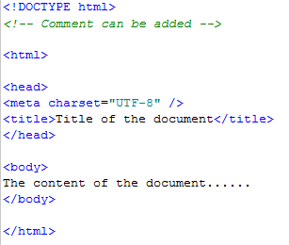

* + - 1. <h1>, <h2>, <p> tags with relevant text of your own
      2. <img> tags using the images on Moodle as well as some of your own. Make sure that the images are displayed in the browser. If not, check the value/path of the **href** attribute
      3. Attributes
         1. Ones that are mandatory such as alt with the <img> tag
         2. Ones that are optional such as width with the <img> tag
      4. <a> tags which create text hyperlinks to local and external web pages
      5. <a> tags which create image hyperlinks to other web pages
      6. <a> tags which create named anchors to move quickly from one part of a web page to another part of the same page
      7. Self-closing tags like <br /> and <hr />
      8. Style attributes added to some of the tags
      9. Comments that you have added
      10. Special characters eg.
          1. Pound - £
          2. Copyright - ©
          3. Less than or equal to 5 - ≤
      11. Lists:
          1. Bulleted list
          2. Ordered list
          3. Lists with attributes

**New Lab Sheet**

1. Create a new web page called ‘staff.html’.
   1. Create a table to store staff contact details as follows:



* 1. Add a heading Add a heading ‘Staff Directory”
  2. Add a caption ‘Internal use”
  3. Add an additional column to store email addresses for each staff
  4. Add email addresses into the last column as links that will open an email application and add the text “Staff Details” as a subject header. Use the email format [firstname.lastname@uws.ac.uk](mailto:firstname.lastname@uws.ac.uk)
  5. The table should be displayed as follows:

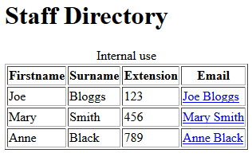

* 1. Add 5 additional records of your own.

1. Create a new web page called ‘form.html’.
   1. Add the relevant HTML code to create a contact form as follows:

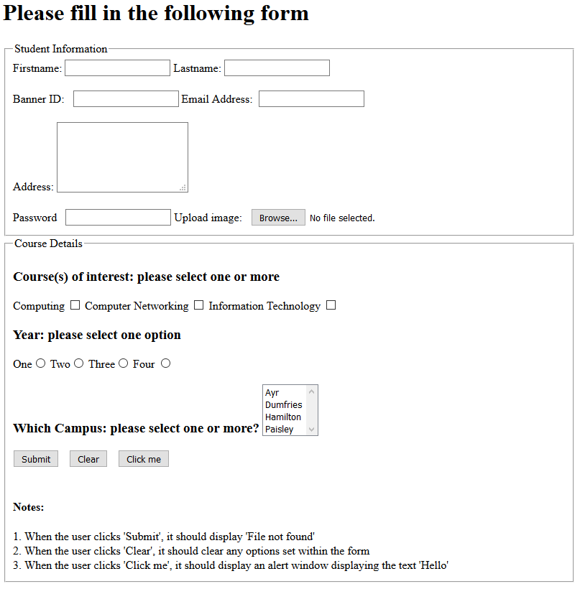

1. Multimedia
   1. Download the images, audio and video sample files from the sub folders within the ‘Sample files’ section on Moodle
      1. Images - Eg bungee.jpg, virus.jpg, worm.jpg, dog.jpg
      2. Audio – Eg track1.mp3, track2.mp3, track3.mp3
      3. Video – Eg gizmo.mp4, samplevideo1.mp4, samplevideo2.mp4
   2. Search and download some other free files (Check the different formats available and research converters for different media formats)
   3. Add some multimedia into your web pages
   4. Include some videos from YouTube into some of your web pages
2. Local/Remote files
3. View your web pages in different browsers locally (ie from your USB drive)
4. Check all pages are displayed, including images
5. Upload your files and folders (eg images) using an FTP client
6. View your web pages in different browsers remotely (ie from the media server). Refer to notes below.
7. Check all pages are displayed, including images
8. Continue to try out examples and quizzes at <http://w3schools.com>

**Important Notes:**

1. If you created files in a folder called week3 and the folder week3 has been uploaded correctly onto your account on the media server, the url for the home page should be: <http://media.uws.ac.uk/iwd~XXX/week3/index.html>
2. Remember, all the files for a web site should be kept in the same folder with a separate folder for images and other multi-media files.
3. Eg. If you have a folder within week3 called images and you have an image called logo.jpg then the code for the image to be displayed should be:

**<img src=”images/logo.jpg” alt=”logo” />**

1. Eg. If you have a folder outwith week3 called images (which is one level above where the index.html file and other files are saved) and you have an image called logo.jpg then the code for the image to be displayed should be:

**<img src=”../images/logo.jpg” alt=”logo” />** where the double dot (..) represents one level above the current level. This option is the better option, especially when you want to use some of the same images on different weeks. This avoids duplication of images (files) in multiple folders and is more efficient.

1. You **MUST** ensure that all references to files and multi-media are relative and not absolute so that when you upload folders and files, the references in the code will still work and the pages are displayed properly from the media server.
2. It is worth thinking about the assessment theme so that you can start to look for relevant files (text, images, audio and video) for your assessment.